

**MASTER’S IN DATA SCIENCE**

**2021-2022**

**Final Master’s Thesis**

**SPAIN’S MEDICINE ADMISSIONS APP**

**Author: Miguel Monedero Rubio**

# TABLE OF CONTENTS

# Page

# 1. INTRODUCTION 4

# 1.1 Context summary 5

# 1.2 Objective 6

# 1.2.1 Objective of this project 25

# 1.2.2 Objective of this document 25

# 1.3 Repository 7

# 2. DATA OBTENTION 19

# 2.1 Web page 7

# 3. DATA QUALITY 20

# 3.1 Data quality challenges 7

# 3.2 How they have been solved 7

# 4. FEATURE ENGINEERING 20

# 4.1 Table schema 7

# 5. MODELLING 20

# 6. FRONT-END 20

# 7. CONCLUSION 20

# 1. INTRODUCTION

# 1.1 Context summary

Historically, Medicine has always been one of the most demanded careers to study in Spain. Nowadays, it’s still one of the hardest careers to get in, due to the high demand of people wanting to study this career in a public university (because of economic pricing, big different in comparison to a private university, plus reputational reasons) and the very few available slots.

To be able to study this career in Spain, you need to achieve a certain average score in “Selectividad”. “Selectividad” is the popular name given to the Spanish University Admission Tests ("Evaluación de Acceso a la Universidad", E.v.A.U.), a non-compulsory exam taken by students after secondary school, necessary to get into university. Students must take six 90-minute written exams over three days in June/July, consisting of common and specific subjects taken in "Bachillerato" (the last two non-compulsory years of secondary education). “Selectividad” exams are set by the Public Universities of each [autonomous community](https://en.wikipedia.org/wiki/Autonomous_communities_of_Spain) and allow students access to the Spanish university system.

Once you do “Selectividad” the universities publish the score you need in order to enter their university, this score is a number ranging from 0 to 14. They publish these scores in the web pages corresponding to each university, meaning that applicants need to consult these scores in each of the university web pages, making it hard to have a holistic view. There are a few web pages that consolidate this information and put it in one single place to have centralized platform. However, these web pages just so a table containing the scores from the different universities and do not show any visualizations or filters in order to facilitate users consult this information.

# 1.2 Objective

# 1.2.1 Objective of this project

There are two objectives for this project:

1. Predict next year scores
2. Create a centralized and accessible place, in this case it will be a web app, to consult the different Medicine admission grades from all the universities in Spain, in a visual and helpful manner. This app will help people save time by not having to go to each of the universities web pages to consult the different scores. Also, it will help guide the user in order to help them make the decision that works best for them.

# 1.2.2 Objective of this document

The objective of this document is to explain the end-to-end process of creating this project, going into detail on the challenges found and the decisions made along the way.

# 1.3 Repository

Take from readme

# 2. DATA OBTENTION

In this section we will be describing the source from which we got the data to do this project.

# 2.1 Web page

The source of data is coming from a web page called “**ACCESO A LAS FACULTADES DE MEDICINA DE ESPAÑA Y NOTAS DE CORTE”** that you can find in the following link:

* <https://sites.google.com/site/notasdecorte/>

The data we are using is found on the left side of the web page *(“Notas de corte de medicina year/year+1”)*, see figure 1:

**Figure 1: Web page from which data was taken**

There is data going from the period of year 2010-2011 till 2021-2022, this is, a total of 12 years:

1. 2010/2011
2. 2011/2012
3. 2012/2013
4. 2013/2014
5. 2014/2015
6. 2015/2016
7. 2016/2017
8. 2017/2018
9. 2018/2019
10. 2019/2020
11. 2020/2021
12. 2021/2022

Each year has its own excel file. Example of data that can be found in year 2010-2011 can be seen in figure 2:

**Figure 2: Medicine admission scores for year 2010-2011**

The columns shown above are the following:

1. “Notas de corte de Medicina”: names of the different public universities
2. “Última fecha admisión (Fecha de la nota final)”: date in which the last list (final grade) is published
3. “Nota de corte final de Medicina”: last list published (final grade), this is, the last score published meaning it’s the lowest score in order to be admitted to that university
4. “1ª Lista”: first list published, therefore the highest score. This score is ranging between 0-14.
5. “Sobre 10”: here they are showcasing the score corresponding to an Nª List but in range 0-10 instead of 0-14. Since this is rarely used, for the purpose of the project we will be analyzing the scores ranging between 0-14.

# 3. DATA QUALITY

In this section we will be describing the different data quality challenges we faced creating this project and how we solved them.

# 3.1 Data quality challenges

Since the data source is coming from 12 different excel files, we need to take into account the following:

* **Column names containing scores:** make sure the columns containing the scores are consistent, and in case they are not, create a standardized column name. Also, make sure they are all a certain type of data, in this case, float.
* **University names**: make sure they are consistent throughout the different years, and in case they are not, create a standardized name.
* **Null values**: records that have null values across all the columns should be deleted.
* **Duplicated values:** make sure we do not have any duplicated values.

# 3.2 How they have been solved

# 3.2.1 Column names containing scores

We have created 2 new columns called “1_list” and “final_grade” to have a standard name since in there were consistency issues between the different data sources. Example:

The column “final_grade” has different names:

* Year XXX: “Nota de corte final de Medicina”
* Year XXX: “Nota de corte final”
* Year XXX: “Nota de corte actual”

# 3.2.2 University names

We have taken the names of the last year (2021) as reference, and we realized 2 things:

1. There are 13 universities which have a different name than the ones in 2021 data, and need to be mapped

To solve this, we used the function sequencematcher

1. There are different number of universities per year

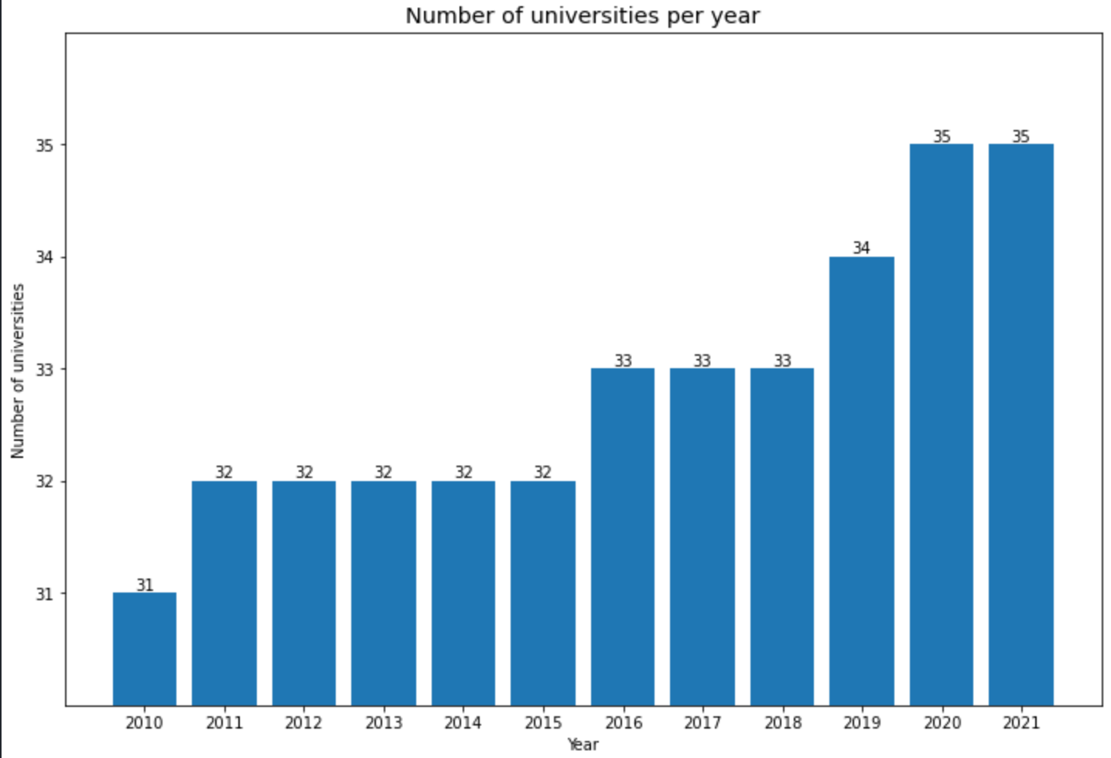

# 3.2.3 Null values

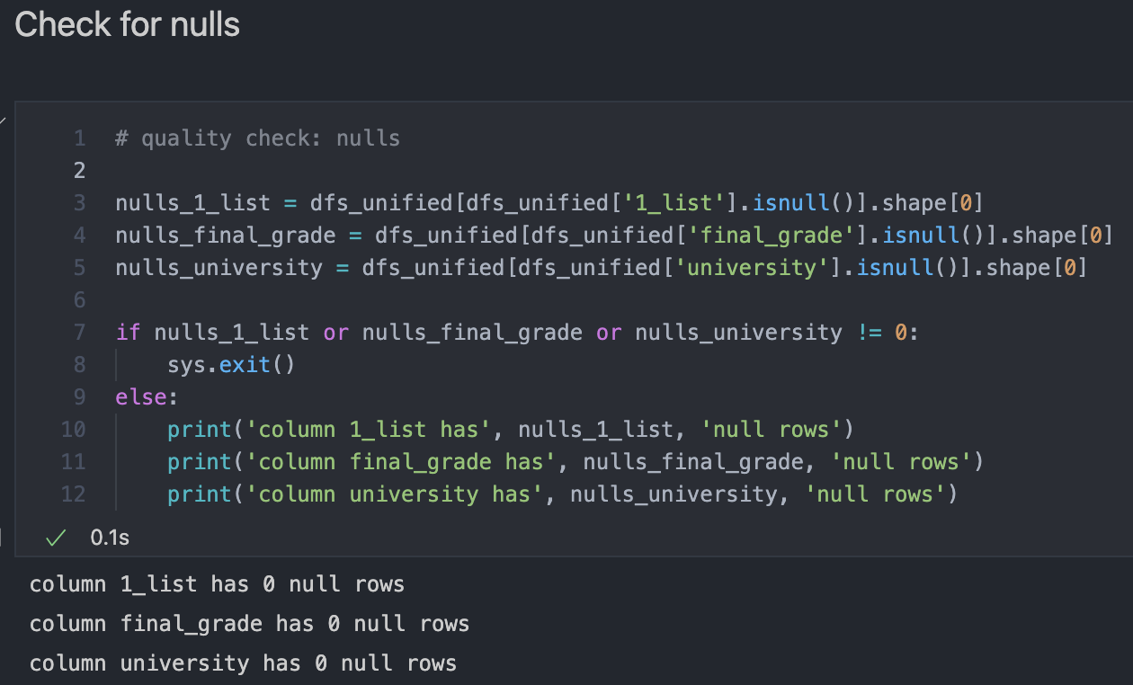

# 3.2.4 Duplicated values

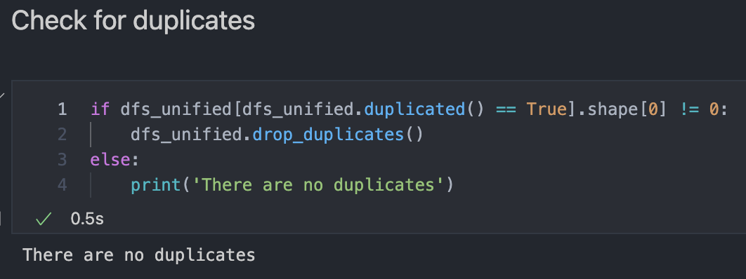

# 4. FEATURE ENGINEERING

In this section we will be describing the different features that have been added in order to be considered in the correlation matrix described in section 5 (Modelling). Also, we will be defining the columns that we had already created before this section. The way we are going to do these 2 tasks is by creating a table schema of all the columns.

# 4.1 Table schema

Columns we previously had before this section:

* **year**
  + Indicates the year from which the data is. Values range from 2010 to 2021. In section 5 (Modelling) we will be predicting the scores for 2022 and will be adding them to the existing table, therefore values will range from 2010 to 2022
* **university**
  + String containing the university name
* **1_list**
  + Float containing the first score published
* **final_grade**
  + Float containing the last score published
* **since_2010**
  + Indicates whether the university has been teaching the medicine career since 2010 or not. In case it does, value of this column is “True”. If not, the value will be the year from which that university has been teaching the career

Columns added:

* **city**
  + String that contains the city in Spain where they university is
* **CCAA**
  + String that contains the Spanish community corresponding to the university
* **covid_format_change**
  + Due to COVID-19 the format of the tests from “Selectividad” changed, making it easier to achieve higher scores since you had more flexibility in choosing one question or the other. This field has two different values, 1 if the year is >= 2020

and 0 if it’s < 2020

GRAFICO DE CRECIMIENTO <2020 y post

* **diff_1_list**
  + Float that is the difference of the 1_list column between the current year and the previous year. For year 2010, this column’s value is NaN since we don’t have data from the previous year (2009)
* **diff_final_grade**
  + Float that is the difference of the final_grade column between the current year and the previous year. For year 2010, this column’s value is NaN since we don’t have data from the previous year (2009)
* **diff_1_list_final_grade**
  + Float that is the difference between the 1_list and final_grade columns for the current year
* **latitude**
  + Float containing the latitude corresponding to the location of the university. Values have been extracted from this web page: <https://www.mapcoordinates.net/es>
* **longitude**
  + Float containing the longitude corresponding to the location of the university. Values have been extracted from this web page: <https://www.mapcoordinates.net/es>

# 5. MODELLING

In this section we will be predicting the 1_list scores for 2022. In order to do so, we will need to analyze which models and variables to use. As the output variable (1_list) is a number we need to solve a regression problem. Therefore, models that we will be analyzing are Linear Regression and ARIMA.

# 5.1 Correlation matrix

To analyze the linear correlation between variables, we have created a correlation matrix. Please see figure X:

**Figure X: Correlation matrix**

As we can see in the figure above, highlighting the output variable (1_list) we can see that the variables with higher linear correlation are:

* **year**: 0.79
* **final_grade**: 0.92
* **covid_format_change**: 0.66
* **diff_1_list**: 0.34

We will be using these variables in the models below to analyze which combination has the lowest error.

# 5.2 Linear Regression

In this section we will be using the data before 2021 as training data and the year 2021 as test data. The reasoning behind this choice is that as we have shown above, the scores incremented considerably do to the change in the test format (due to COVID-19) in 2020. This way we could train the model considering this year and predict more efficiently the scores for 2021 (tests this year also had the format applied due to COVID-19).

In the next sections we will be showcasing the results obtained by using different variables in the model.

# 5.2.1 Variables: [‘final_grade’]

First model training was done with the variable “final_grade”, which was the one that we saw above that had the highest correlation (0.92), with the target variable. Please see in figure X the results obtained:

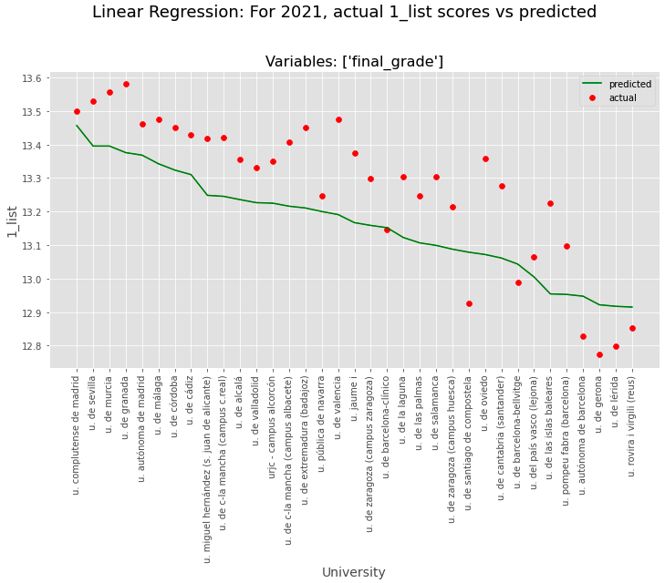

**Figure X: Linear Regression – variables: final_grade**

Analyzing the graph above, we can see that as a base model, the model has predicted a similar trend than the actual data, although a bit lower scores than expected.

# 5.2.2 Variables: [‘final_grade’, ‘year’]

Second model training was done with the variables “final_grade” and “year”, which were the two variables with highest correlation (0.92 and 0.79, respectively). Please see in figure X the results obtained:

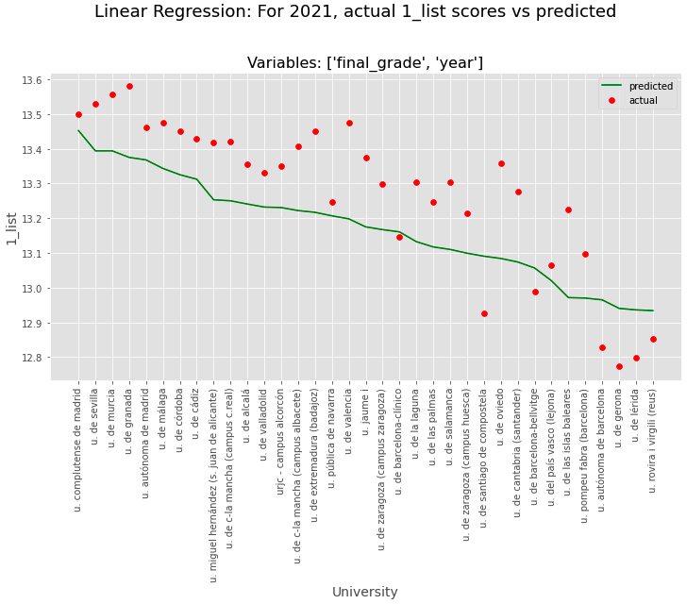

**Figure X: Linear Regression – variables: final_grade, year**

Analyzing the graph above, we can see that the prediction is very similar to the previous one where we used only the variable “final_grade”. There is still room for improvement.

# 5.2.3 Variables: [‘final_grade’, ‘year’, ‘covid_format_change’]

Third model training was done with the variables “final_grade”, “year” and “covid_format_change”, with the following correlations: 0.92, 0.79 and 0.66, respectively. Please see in figure X the results obtained:

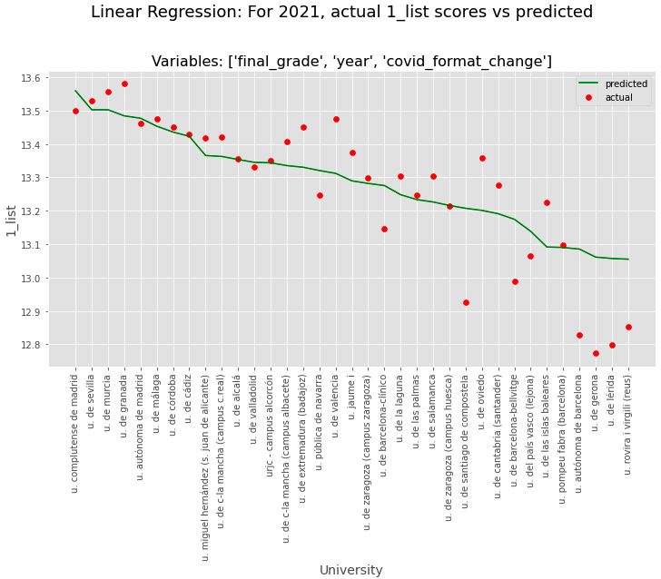

**Figure X: Linear Regression – variables: final_grade, year, covid_format_change**

Analyzing the graph above, there is a significant difference between this prediction and the 2 previous ones. In general terms, it seems as there is less error. We will analyze this in detail in the section where we calculate the metrics (MAE, MSE, RMSE) obtained.

# 5.2.4 Variables: [‘final_grade’, ‘year’, ‘covid_format_change’, ‘diff_1_list’]

The fourth and last model training (for Linear Regression) was done with the variables “final_grade”, “year”, “covid_format_change” and “diff_1_list”, with the following correlations: 0.92, 0.79, 0.66 and 0.34, respectively. Please see in figure X the results obtained:

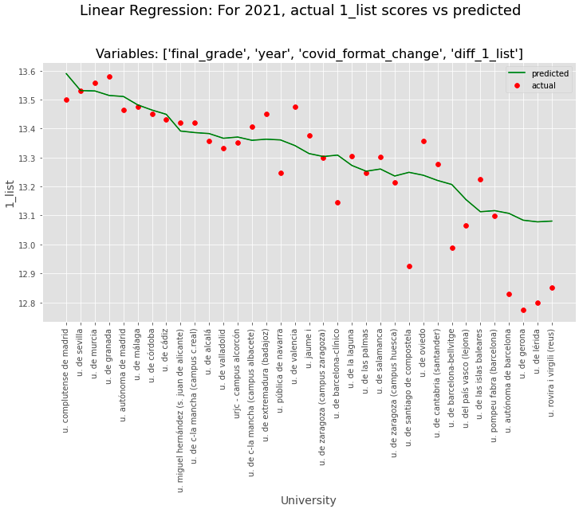

**Figure X: Linear Regression – variables: final_grade, year, covid_format_change, diff_1_list**

Results seem to be similar to the ones obtained with the 3 variables: final_grade, year, covid_format_change. Error might be slightly higher due to the fact that this time we have trained the model with a variable with a not very high linear correlation (diff_1_list: 0.34). We will analyze this in detail in the metrics section.

# 5.3 Linear Regression per university

In this section we will be doing the same methodology we did before, using the data before 2021 as training data and the year 2021 as test data, but doing this per university. Therefore, we will be creating 35 different models.

In the next sections we will be showcasing the results obtained by using different variables in the model.

# 5.3.1 Variables: [‘final_grade’]

First iteration training the 35 models was done with the variable “final_grade”. Please see in figure X the results obtained:

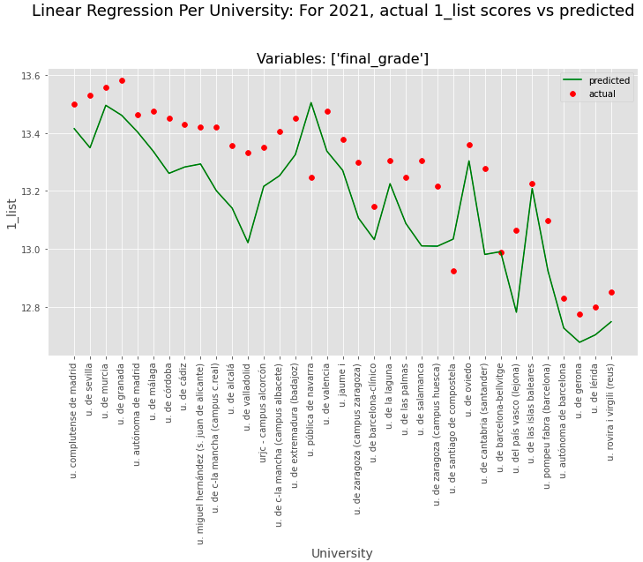

**Figure X: Linear Regression per university – variables: final_grade**

Analyzing the graph above, we see that the prediction is not almost a “straight” line as we were seeing before, but rather a more targeted prediction because in this case we are doing one model per university. Overall, the predictions seem a bit lower than the actual score, there is still room for improvement.

# 5.3.2 Variables: [‘final_grade’, ‘year’]

Second iteration training the 35 models was done with the variables “final_grade” and “year”. Please see in figure X the results obtained:

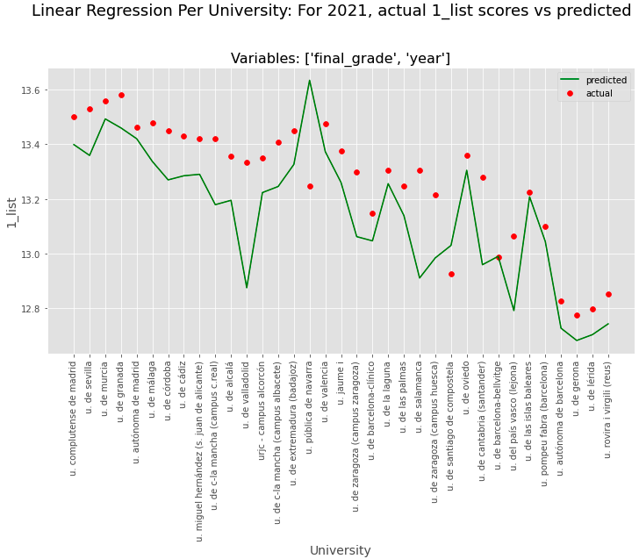

**Figure X: Linear Regression per university – variables: final_grade, year**

Similar trend as the previous scenario seen with only the variable “final_grade”. In general terms, predicted scores seem lower than actual ones.

# 5.3.3 Variables: [‘final_grade’, ‘year’, ‘covid_format_change’]

Third iteration training the 35 models was done with the variables “final_grade”, “year” and “covid_format_change”. Please see in figure X the results obtained:

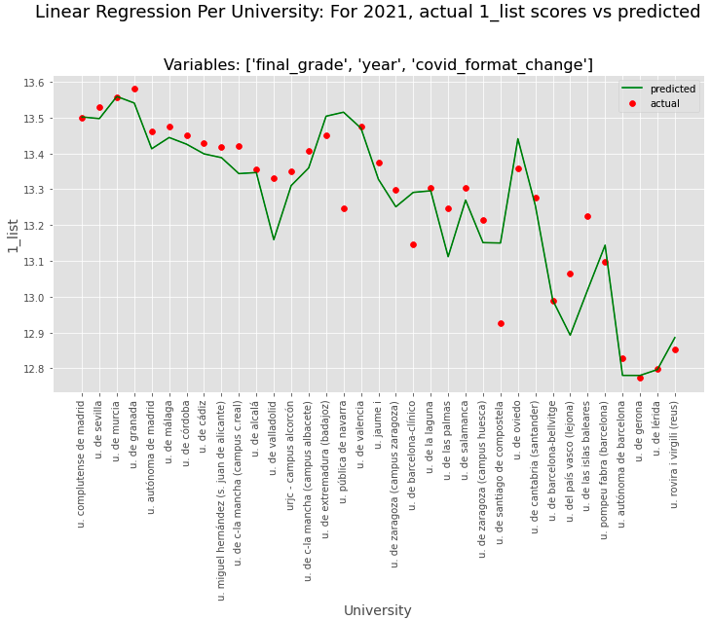

**Figure X: Linear Regression per university – variables: final_grade, year, covid_format_change**

Analyzing the graph above, we can see that the predicted scores are noticeably more accurate than the first two iterations. The predicted scores don’t seem as low as in the other iterations in comparison to the actual ones.

In the metrics section we will most likely see this combination (Linear Regression per university models using variables final_grade, year and covid_format_change) as one of the ones, or the one, with less error.

# 5.3.4 Variables: [‘final_grade’, ‘year’, ‘covid_format_change’, ‘diff_1_list’]

Fourth and last iteration training the 35 models was done with the variables “final_grade”, “year”, “covid_format_change” and “diff_1_list”. Please see in figure X the results obtained:

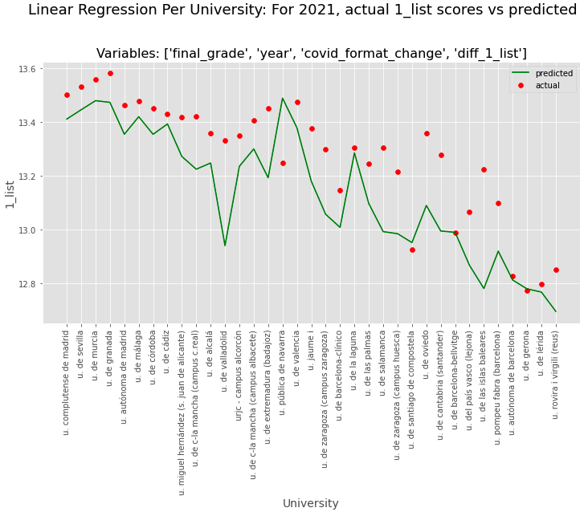

**Figure X: Linear Regression per university – variables: final_grade, year, covid_format_change, diff_1_list**

Since in this case we are introducing a variable with low linear correlation (diff_1_list: 0.34) we could have expected that the model prediction would be worse than without this variable and indeed, looking at the graph above we see that the predicted scores are not as accurate and are overall quite below the actual scores.

# 5.4 ARIMA

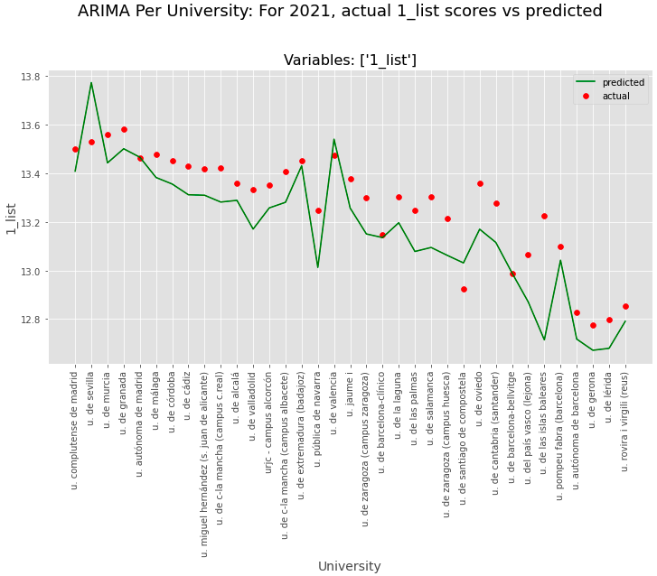

**Figure X: ARIMA per university – variables: 1_list**

# 5.5 Metrics

Explicar MAE, MSE, RMSE

# 5.6 Predict next year (2022) 1_list scores